MEDIA RELEASE
For Immediate Release
DISCOVER THE STORIES BEHIND HERITAGE BUSINESSES IN CHINATOWN THAT HAVE STOOD THE TEST OF TIME!
Singapore, 15 September 2022 – The heritage businesses of Chinatown are full of stories of hard work, dedication, and resourcefulness. From restaurants, confectioneries and tea merchants to goldsmiths and traditional Chinese medicine shops, they embody the ethos of the communities who live in the area.

2. The National Heritage Board (NHB) will be launching its Street Corner Heritage Galleries for Chinatown on 15 September 2022 with 11 participating heritage businesses. The scheme will celebrate and document the rich experiences of these businesses, which have thrived over the years and evolved to remain relevant to their customers today.

3. Under this scheme, NHB works closely with interested owners of heritage businesses with at least 30 years of history to co-curate and co-create “mini-museums” at their premises that showcase the history and heritage of their businesses and trades, accompanied by historical documents, photographs, artefacts, etc.

4. Street Corner Heritage Galleries: Chinatown will feature 11 heritage businesses in the precinct comprising Eu Yan Sang, Chop Wah On, Spring Court Restaurant, Mei Heong Yuen, On Cheong Jewellery, Tin Sing Goldsmiths, Kim Poh Hong Goldsmith, Bee Cheng Hiang, Lim Chee Guan, Tong Heng and Pek Sin Choon. Please refer to Annex A for the full write-ups of all participating heritage businesses.

5. The Street Corner Heritage Galleries scheme is part of NHB’s ongoing efforts under Our SG Heritage Plan to strengthen partnerships with communities, and raise awareness of and foster a deeper appreciation for heritage in everyday spaces. It is a three-year pilot scheme which was first launched in the Balestier precinct in March 2020, followed by the Kampong Gelam precinct in April 2021 and the Little India precinct in January 2022. The scheme will subsequently be rolled out to the Geylang Serai precinct in 2023.

6. In a nutshell, the scheme provides curatorial support in terms of research and content development, and funding for the fabrication of showcases. It also provides funding support for heritage businesses to present programmes such as talks, tours and workshops, and provides them with opportunities to participate in NHB’s signature events such as Singapore HeritageFest.

7. Mr Alvin Tan, Deputy Chief Executive (Policy & Community), NHB said: “Through our expanding network of street corner heritage galleries, we hope to raise public awareness and generate greater support for heritage businesses; equip the owners of these businesses with the necessary skills and experience to better showcase their heritage; and in doing so, activate the various precincts as “living showcases” of heritage businesses.”

8. Please refer to Annex A for an introduction to the 11 Street Corner Heritage Galleries in Chinatown, and Annex B for the list of artefacts. Street Corner Heritage Galleries: Chinatown can also be explored on: http://go.gov.sg/schgchinatown.
- end -

For media enquiries, please contact:

Jamie Choy | Raelynn Tan
Tate Anzur | Tate Anzur
9776 2223 | 8300 1975
jamie.choy@tateanzur.com | raelynn.tan@tateanzur.com

About the National Heritage Board

The National Heritage Board (NHB) was formed on 1 August 1993. As the custodian of Singapore’s heritage, NHB is responsible for telling the Singapore story, sharing the Singaporean experience and imparting our Singapore spirit.

NHB’s mission is to preserve and celebrate the shared heritage of our diverse communities, for the purpose of education, nation-building and cultural understanding. It manages the national museums and heritage institutions, and sets policies relating to heritage sites, monuments and the national collection. Through the national collection, NHB curates heritage programmes and presents exhibitions to connect the past, present and future generations of Singaporeans. NHB is a statutory board under the Ministry of Culture, Community and Youth. Please visit www.nhb.gov.sg for more information.

ANNEX A
Street Corner Heritage Galleries: Chinatown
- Medical Care for Mankind
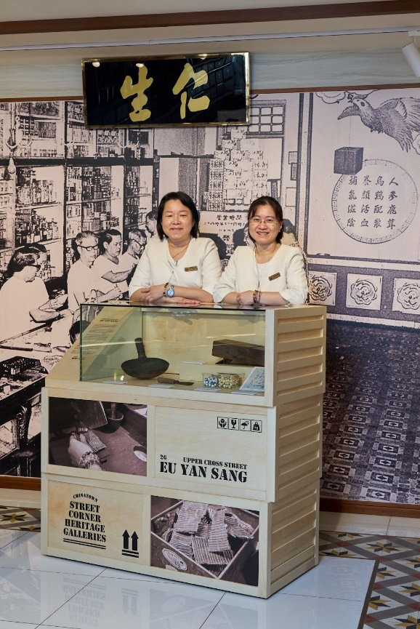
Eu Yan Sang
26 Upper Cross Street, Singapore 058336
The story of Eu Yan Sang starts in 1873 when Eu Kong, an immigrant from Guangdong, China, arrived in Perak, Malaya where he observed that tin miners often turned to opium to ease their pains.
Convinced that traditional Chinese medicine could provide better pain management and treat ailments, Eu opened a medical hall in Gopeng, Perak in 1879, naming it Yan Sang, which translates to “caring for mankind” in Cantonese.
When Eu Kong passed away, his son, Eu Tong Sen, took over the business at the age of 21. Armed with an astute business acumen, Tong Sen expanded the family’s business from traditional medicine to tin mines, rubber plantations and properties. Determined to free tin miners from their opium addiction, he set up medical halls near his tin mines to provide medical care for them.
By the 1910s, the family’s traditional Chinese medicine business, rebranded as Eu Yan Sang, had extended to Singapore, Hong Kong, and southern China. In 1910, the first Eu Yan Sang medical hall in Singapore opened at 265-271 South Bridge Road. Besides providing affordable healthcare and medical supplies, Eu Yan Sang medical halls provided remittance services and its shop assistants would help illiterate migrants read and pen letters.
Today, Eu Yan Sang continues the founder’s mission of caring for mankind through traditional medicine, operating over 200 retail outlets and clinics in the region.

- Trusted Medicated Oils and Balms
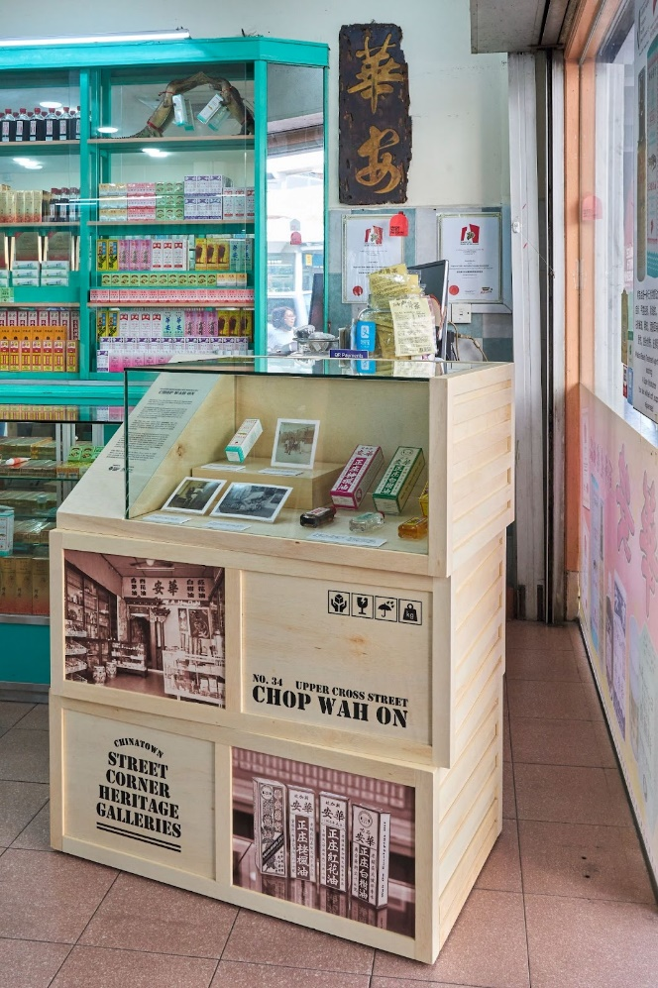
Chop Wah On
No. 34 Upper Cross Street, Singapore 058340
Founded by Tong Chee Leong in 1916 at 67 Pagoda Street, Chop Wah On is one of the oldest medicated oil and balm companies in Singapore.
Reputed for its quality yet affordable products, Chop Wah On was a popular stop for Chinese coolies and Samsui women returning to China to stock up on gifts, in particular its Red Flower Oil. Tong’s eldest son, Tong Seng Mun, took over the business in the 1940s and continued to keep prices low for its working-class customers.
The shop not only serves local customers, but also customers from China, where Chop Wah On has built a strong reputation thanks to generations of returning immigrants bringing its products home as gifts for family and friends.
An animal enthusiast, Tong operated an exotic animal trade from the back of the Pagoda Street shophouse up to the 1960s, supplying animals to research institutes and zoos overseas. The family recalled the Sultan Ismail of Johor, a friend of Tong and fellow animal enthusiast, visiting the shophouse incognito to view the animals a number of times. In 1957, Tong also opened a zoo in Pasir Panjang, complete with a sea lion from the Netherlands.
Chop Wah On relocated to Upper Cross Street in 2000 and is now run by the third generation of the Tong family who continues to build upon the trust and loyalty from generations of customers who swear by its remedies.

- Cantonese Cuisine for Local Palates
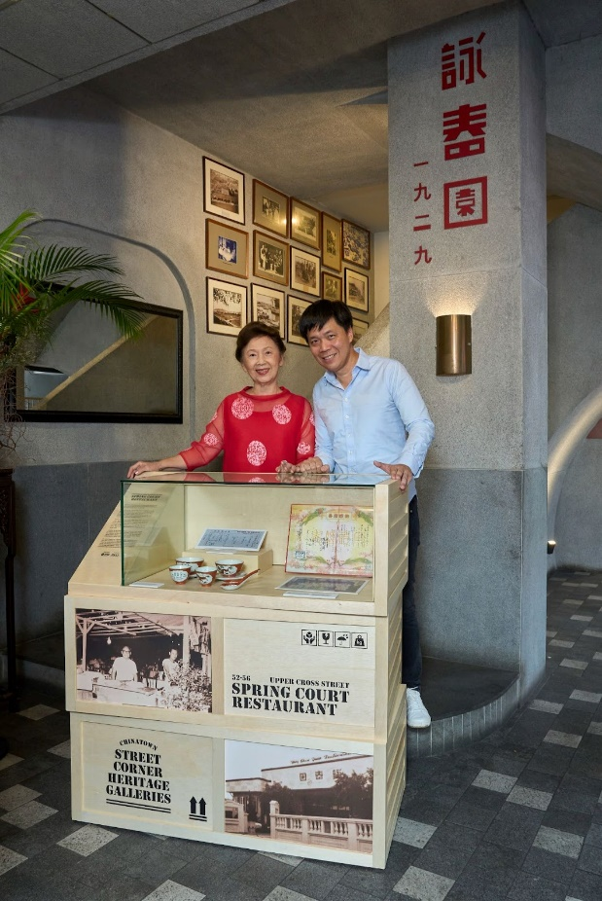
Spring Court Restaurant
52-56 Upper Cross Street, Singapore 058348
One of the oldest restaurants in Singapore, Spring Court was established at Great World Amusement Park in 1929 by lorry driver turned restaurateur Ho Loke Yee.
Originally named Wing Choon Yuen (“singing in a spring garden” in Cantonese), the restaurant was reputed for its localised Cantonese fare, which incorporated ingredients from Malay, Indian, Hokkien and Teochew cuisines, such as chilli and curry powder, and featured stronger flavours than traditional Cantonese cuisine.
During the 1930s to 1960s, Wing Choon Yuen was where the elite, dignitaries, associations and newlyweds would flock to for celebratory feasts. With its capacity of 100 tables, the restaurant often hosted three or four wedding banquets per night. In fact, business was so brisk that Ho often had to sleep over at the restaurant on a makeshift bed of dining tables.
However, by the 1970s, business declined as the number of visitors to Great World dwindled. Wing Choon Yuen then relocated to New Bridge Road in 1978, renaming itself Spring Court while retaining its Chinese name, before settling at Upper Cross Street in 2004.
For many Singaporean Chinese families, celebrating Lunar New Year at Spring Court has become an annual tradition. Today, the restaurant is run by the third generation of the Ho family who remains committed to preserving local Chinese food heritage and offering a Singaporean interpretation of Cantonese cuisine to the younger generation.

- From Peanuts to Traditional Desserts
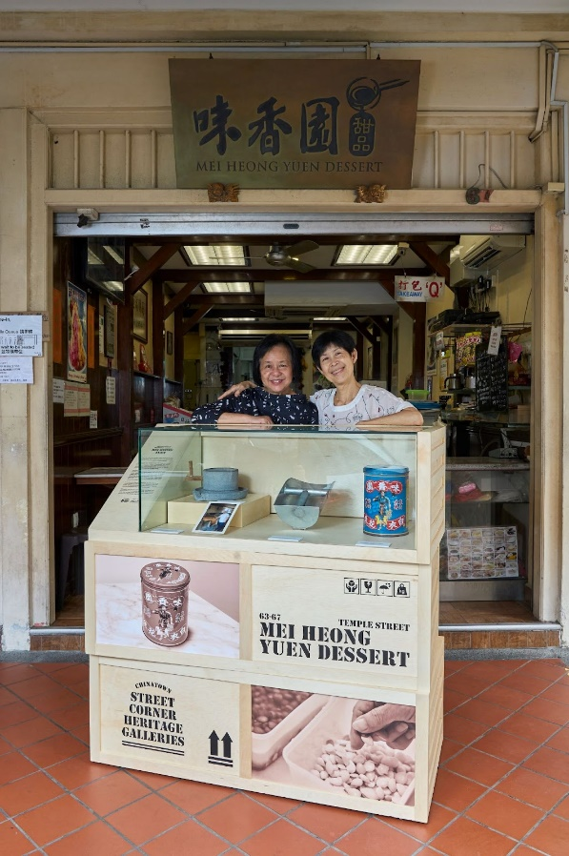
Mei Heong Yuen
63-67 Temple Street, Singapore 058611
Known for its traditional desserts today, few might be aware that Mei Heong Yuen (“fragrant garden” in Cantonese) first began operations as a producer of roasted peanuts.
The business was founded by Lee Chit Heng, who worked in the roasted peanut industry in Menglembu, Ipoh, before relocating to Singapore in the 1940s. Lee established Mei Heong Yuen, which sold Menglembu peanuts on Pagoda Street before relocating to 39 Temple Street.
Marketed under the name Farmer Brand, Mei Heong Yuen supplied peanuts to local retailers and restaurants, while freshly roasted peanuts were sold by weight at Temple Street. By the 1970s, its peanuts were exported to Southeast Asia, Hong Kong, Europe, and the United States. While exports continued to flourish in the 1990s, business on Temple Street faced stiff competition with the introduction of more novel snacks in the market.
In an attempt to diversify the business and retain Mei Heong Yuen’s presence in Chinatown, Lee’s daughters, Clara and Connie, came up with the idea of selling traditional Cantonese desserts at the family’s shop at 67 Temple Street.
The venture proved successful and Mei Heong Yuen has expanded with several outlets across the island, and as a nod to their heritage, Farmer Brand peanuts continue to be sold at some of their dessert shops today.

- From Traditional to Fine Jewellery
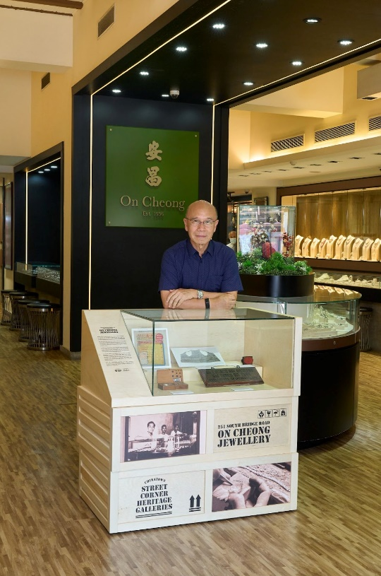
On Cheong Jewellery
251 South Bridge Road, Singapore 058800
Known for its craftsmanship and unique jewellery designs, On Cheong was founded in 1936 by Ho Yew Ping who immigrated from Guangdong, China in 1925 and apprenticed at various goldsmiths in Malaya before moving to Singapore.
Ho set up his first shop with friends at North Bridge Road selling silver and gold accessories and named the business On Cheong, which translates to “peace and prosperity” in Cantonese, reflecting the desires of immigrants in those uncertain times.
In 1941, Ho relocated On Cheong to 251 South Bridge Road as he hoped that Chinatown’s higher population density would result in more customers and, as a Cantonese person himself, felt that it would be easier doing business with a predominantly Cantonese clientele.
Up till the 1990s, On Cheong was primarily a trusted goldsmith for customers who bought gold as a means of savings. However, as more Singaporeans began buying jewellery for personal use, Ho Nai Chuen, the founder’s youngest son, decided to modernise the brand, and started specialising in rare jade pieces and customised jewellery designs.
Now an established purveyor of fine jewellery, On Cheong has successfully pivoted to offering unique jewellery designs and expertly crafted masterpieces to appreciative customers.
- Household Name for Quality Gold
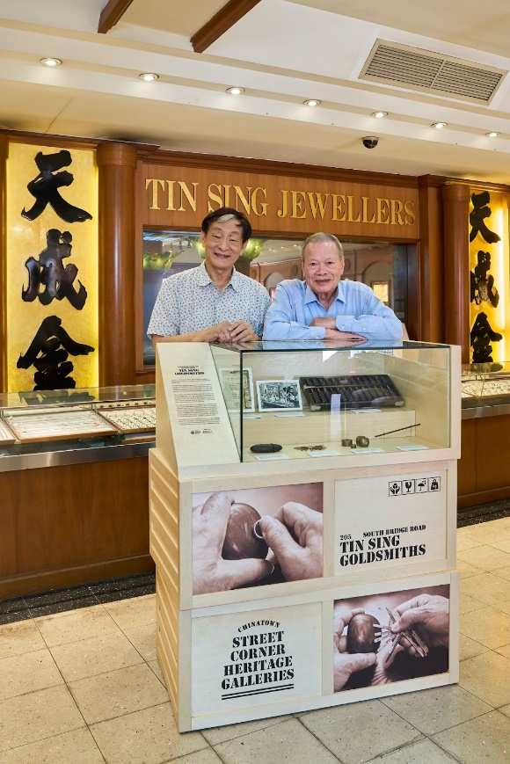
Tin Sing Goldsmiths
205 South Bridge Road, Singapore 058756
Founded in 1937 by the Wong, Wan and Chow families, Tin Sing is one of the last pre-war goldsmiths located along South Bridge Road.
Until the 1970s, gold was regarded as a traditional means of savings and goldsmiths such as Tin Sing often saw customers queuing to purchase gold on pay days. Tin Sing was particularly popular as it guaranteed buyback of its jewellery during a time when few goldsmiths offered such an assurance.
Renowned for the quality of its gold and craftsmanship, Tin Sing employed some 20 master craftsmen at its peak from the 1950s to 1970s. Drawn by Tin Sing’s craftsmanship, patrons like politicians, tycoons’ wives, pageant queens and international celebrities such as Fung Bo-bo, Jenny Tseng and Li Li-hua regularly graced its shop floor.
Tin Sing was also the go-to jeweller for commissioned works, which often made headlines. Examples include a gold medallion depicting two swallows returning to a nest, gifted by a fan in 1952 to Hong Kong Cantonese opera star Sek Yin-Tsi; and a gold medallion commissioned by the Singapore Chinese Chamber of Commerce and Industry, presented as a token of appreciation to then-Prime Minister Lee Kuan Yew at the official opening of the chamber’s building in 1964.
Managed by the second generation of the founding families today, Tin Sing remains a trusted local jeweller and continues to serve long-time customers who return to purchase pieces for special occasions or commission custom designs.

- From Silver to Peranakan Jewellery
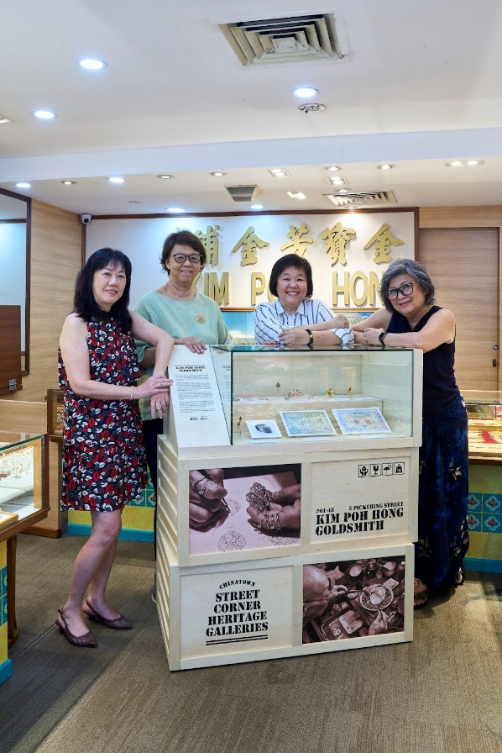
Kim Poh Hong Goldsmith
#01-48 3 Pickering Street, Singapore 048660
For more than 80 years, Kim Poh Hong Goldsmith has been crafting and selling jewellery to generations of customers. The business was founded at 58 China Street in 1938 by Tan Eng Geok, a silversmith who came to Singapore from Kinmen, China.
During its early years, Kim Poh Hong sold silver jewellery from local wholesalers, as well as handcrafted pieces by Tan. Its customers, who were mainly Hokkiens, would frequent the shop to purchase special items such as silver amulet holders for newborns and burial jewellery for the deceased. The shop also traded gold jewellery, notably reddish gold pieces preferred by Hokkien customers.
In 1943, Tan established Poh Huat Goldsmiths at North Bridge Road with friends and by the 1950s, both shops had become known for their workmanship and custom-made jewellery. Poh Huat was frequented more by Malay, Indian and Nyonya customers due to the make-up of the community in the area.
The Tan family bought over Poh Huat Goldsmiths in 1971 when the founders retired and subsequently merged it with Kim Poh Hong. When China Street underwent redevelopment in the 1990s, Kim Poh Hong relocated and eventually settled at Pickering Street in 2002.
Today, Kim Poh Hong is run by the third generation of the Tan family and has carved a niche in designing enamel and Peranakan jewellery.

- Beautiful and Aromatic Barbecued Meat
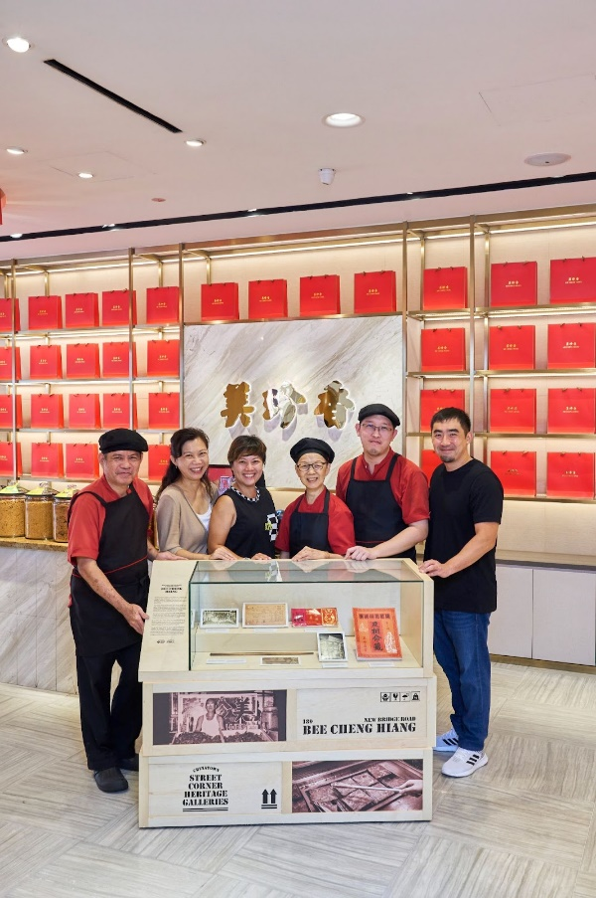
Bee Cheng Hiang
189 New Bridge Road, Singapore 059422
Bee Cheng Hiang started in the 1930s as a roadside stall selling bak kwa (barbecued meat slices) near the former Majestic Theatre in Chinatown. The business was founded by Teo Swee Ee, who subsequently opened his first shop at Rochor Road.
The family named the business Bee Cheng Hiang and each Chinese character of its name is composed of nine strokes to signify longevity in Chinese culture. It is also a representation of the Bee Cheng Hiang experience, where the bak kwa is touted as “beautiful, aromatic delicacies”.
Teo was an astute businessman with strong marketing instincts. From the 1950s, Bee Cheng Hiang, then spelled as “Bee Chun Heng”, advertised regularly, sponsored radio programmes and participated in trade expositions.
By the 1970s, Bee Cheng Hiang had expanded and set up several branches in the city area. This New Bridge Road branch quickly became an icon in Chinatown where queues would form round the block during festive seasons.
Though Bee Cheng Hiang has grown into a multinational company, it continues to employ traditional production methods where possible, such as spreading meat slices on bamboo trays by hand. It is this emphasis on tradition that explains why long-time customers return again and again, for bak kwa which remains true to the taste they grew up with.

- Traditional Taste of Bak Kwa
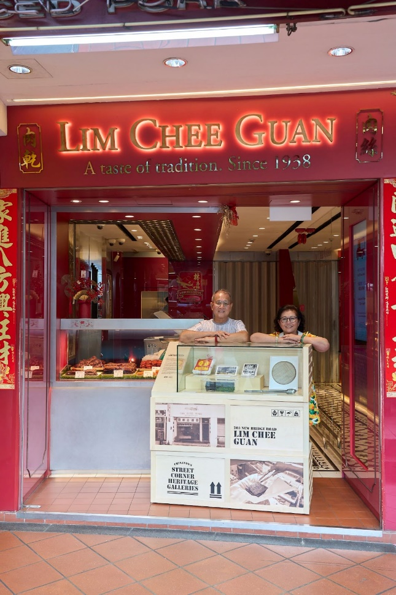
Lim Chee Guan
203 New Bridge Road, Singapore 059429
Famed for its snaking queues during festive periods, Lim Chee Guan was established by Lim Kay Eng who arrived from Fujian, China in the 1920s. Defying his parents’ wishes for him to be a doctor, Lim toiled in plantations and shops before saving enough to start a pushcart business selling bak kwa (barbecued meat slices) along Chin Chew Road in 1938.
Lim named the business “Chee Guan”, which translates to “ambition and integrity” in Mandarin. He made bak kwa using his mother’s recipe and adapted the marinade of the meat to suit local tastes. Lim also experimented with the preparation process, such as sun-drying the meat and barbecuing it over charcoal to give it a distinctive smoky taste.
In 1956, Lim relocated to a rented shophouse along New Bridge Road where half the shop was used for bak kwa production and the other half for retail. Lim and his family would spend most of their free time at the shop and this family tradition of helping out in the business is still practised by the second and third generations of the Lim family, who currently run the business.
To this day, Lim Chee Guan holds a special place in the hearts of its long-time customers, many of whom do not mind the long queues and in fact, regard queuing for the shop’s bak kwa as a Lunar New Year tradition.

- From Traditional Teahouse to Delicious Pastries
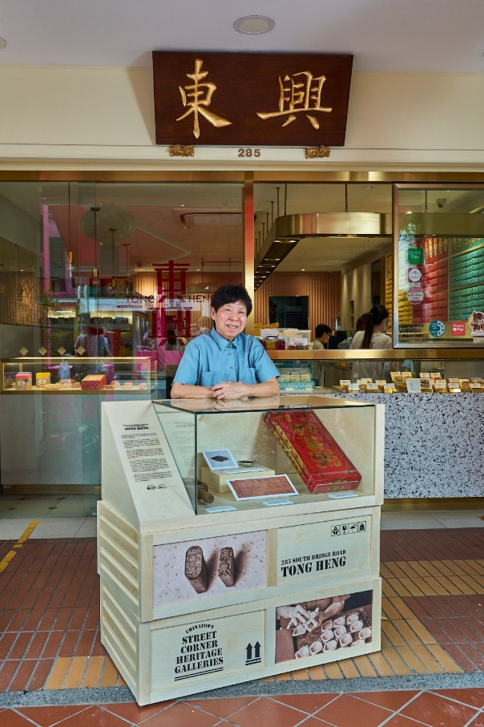
Tong Heng
285 South Bridge Road, Singapore 058833
Recognised for its diamond-shaped egg tarts today, Tong Heng has its roots as a pre-war establishment known as Huang Hou Teahouse.
Its founder, Fong Chee Heng, who arrived in the 1910s from Guangdong, China, started out as an itinerant hawker peddling drinks in various teahouses. With savings accumulated over the years, Fong bought over the teahouse on Smith Street in 1934, which was later renamed Tong Heng.
Teahouses like Tong Heng were a cornerstone of Cantonese culture in pre-war Chinatown, where patrons would gather to drink tea, enjoy confectioneries and chat. Located across from opera theatre Lai Chun Yuen, Tong Heng was also where fans would purchase sweet treats for their favourite stars.
After World War II, many of Chinatown’s teahouses transformed themselves into eating houses, but Tong Heng persevered with the making of confectioneries. In the 1960s, the family installed a showcase displaying egg tarts baked in different shapes to attract more customers. This strategy proved to be highly successful, and Tong Heng became well-known as a confectionery store offering egg tarts and traditional Cantonese wedding pastries.
Tong Heng had to vacate its premises on Smith Street in the 1980s due to the redevelopment of the area and relocated to its current location on South Bridge Road. Today, Tong Heng is run by fourth generation descendants and continues to be an icon of Chinatown.

- Hallmark of Quality Tea
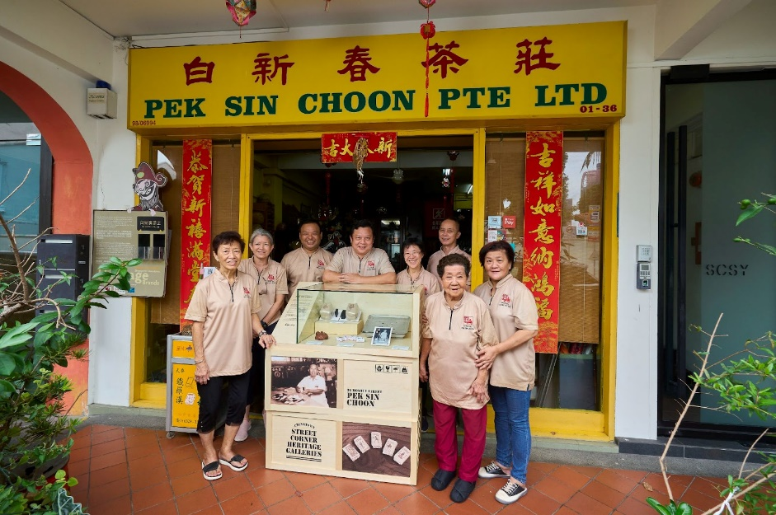
Pek Sin Choon
36 Mosque Street, Singapore 059514
One of the oldest tea merchants in Singapore, Pek Sin Choon was founded in 1925 by Bai-Zhuang Dan Niang and her son Pek Kim Aw.
Bai-Zhuang moved to Singapore in 1910 from Anxi, China after the death of Pek’s father so that Pek could apprentice at his uncle’s tea shop here and learn the trade. Pek left his uncle’s shop after gaining some experience to work in Indonesia as a labourer, before returning to Singapore to set up his own tea business.
To build his own clientele, Pek would carry tea on a shoulder pole, selling it door-to-door to businesses and residents in the city area. By 1925, Pek saved enough to set up his own shop on George Street. He chose the buffalo as the brand’s mascot because he was nicknamed “Buffalo Head'' by his associates due to his strong-headed character. Pek Sin Choon gradually gained a reputation for its quality tea blends over the years.
As quality teas became the hallmark of Pek Sin Choon, Pek instilled a culture where every family and staff member must acquire deep knowledge in the preparation and brewing of tea.
Run by the fourth generation today, Pek Sin Choon continues to be known as a leading wholesaler and retailer of premium Chinese tea and is sought after by clients looking for its bespoke tea blends.
ANNEX B
List of Artefacts
- Eu Yan Sang
No. | Image | Caption
1 | 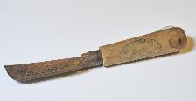 | This knife was used in the past by Eu Yan Sang’s herbalists to slice and trim herbs used in prescriptions.
2 | 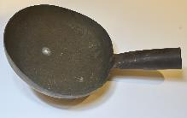 | In certain prescriptions, herbs have to be roasted in pans such as the one on display for greater efficacy.
3 | 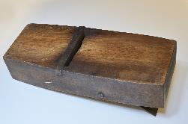 | This manual herb slicer has an adjustable blade to allow the herbalist to slice herbs into different thicknesses according to the requirements of prescriptions.
4 | 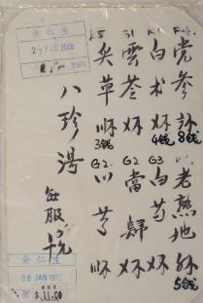 | This hand-written prescription from 1995 contains the formula for ba zhen tang (eight treasures soup), which is commonly prescribed for replenishing vitality and promoting blood circulation.
5 | 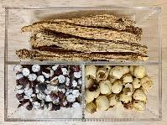 | (Clockwise from top) dang shen (codonopsis), lian zi (lotus seeds), and qian shi (fox nut barley) are commonly prescribed and consumed for their beneficial health properties today as they were by early Chinese migrants in the past.

- Chop Wah On
No. | Image | Caption
1 | 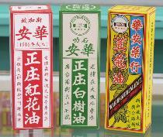 | These were boxes originally used to package Chop Wah On’s founding products, and they bear the shop’s former addresses at 67 Pagoda Street and 7 Smith Street.
2 | 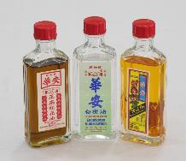 | These products are part of Chop Wah On’s traditional remedies series, which are still sold today. From left to right: Red Flower Oil, Eucalyptus Embrocation and Nutmeg Embrocation.
3 | 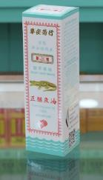 | This is one of the crocodile oil products developed by Tong Seng Mun, who observed that crocodiles heal fast from injuries.
4 | 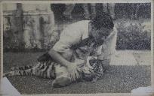 | This photograph, taken between the 1950s-1960s, shows Tong Seng Mun and his pet tiger cub, which often lounged in the shop much to the delight of customers.
5 | 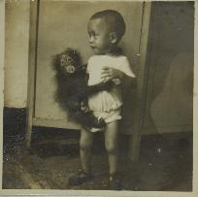 | This photograph, taken in the 1950s, shows Tong Seng Mun’s son, Tong Kok Wing, with a baby orangutan at Chop Wah On, Pagoda Street.
6 | 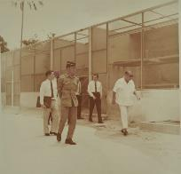 | This photograph, taken in the 1960s, shows Sultan Ismail of Johor (right) with Tong Seng Mun (left) visiting Jurong Bird Park with the Chairman of Jurong Town Corporation Woon Wah Siang (second from right).

- Spring Court Restaurant
No. | Image | Caption
1 | 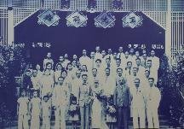  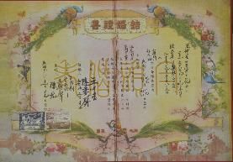 | Top: This photograph shows a wedding banquet held at Wing Choon Yuen when it was located at Great World Amusement Park and regarded as a grand venue to hold weddings.  Bottom: This marriage certificate signed at Wing Choon Yuen in 1949 contains the names of those involved in the wedding, including the matchmakers of the couple.
2 | 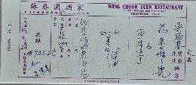 | This receipt was issued by the restaurant in 1961 for a wedding banquet costing $725.35, which was a considerable sum in those days.
3 | 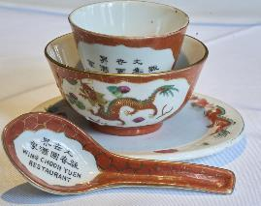 | This collection of crockery was used by the restaurant during wedding banquets in the past, and the bowl and teacup are decorated with dragons, which are considered an auspicious symbol signifying vitality and strength.

- Mei Heong Yuen
No. | Image | Caption
1 | 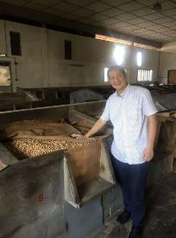 | This photograph of James Lee, son of founder Lee Chit Heng, was taken at the family’s roasted peanuts factory in Malaysia, where Farmer Brand products are still manufactured today.
2 | 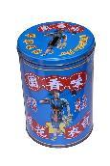 | Farmer Brand peanuts used to be sold in tins such as this one before the company switched to plastic packets.
3 | 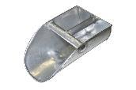 | This scoop was used for peanuts sold by weight at the Temple Street shop before it closed down.
4 | 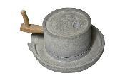 | This stone grinder was used to grind peanuts, almonds and sesame seeds to make Mei Heong Yuen’s signature dessert pastes.

- On Cheong Jewellery
No. | Image | Caption
1 | 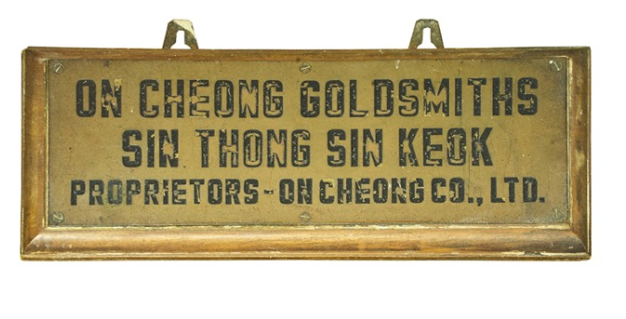 | This business sign bears the names of On Cheong Goldsmiths and its subsidiary Sin Thong Sin Keok, which provided remittance services for Chinese immigrants.
2 | 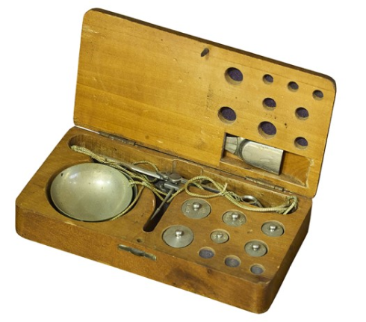 | This set of manual weighing scale and weights was used by On Cheong in the past to measure diamonds.
3 | 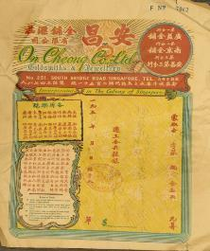 | This receipt, issued in 1959, lists the four goldsmith shops owned by Ho during the 1950s, comprising On Cheong, Kwong Yik Goldsmiths, Nan Jing Goldsmiths, and another branch of On Cheong.
4 | 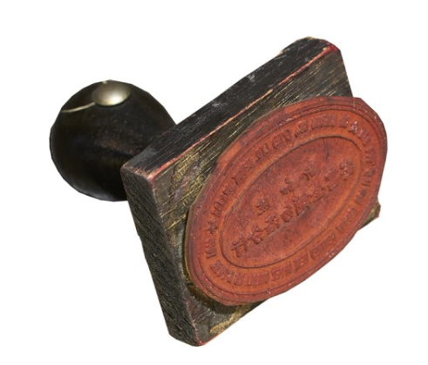 | This old company stamp was used to stamp documents at On Cheong’s branch in Bedok, which opened in 1989 and closed in 1999 as the company opened a larger outlet on South Bridge Road.
5 | 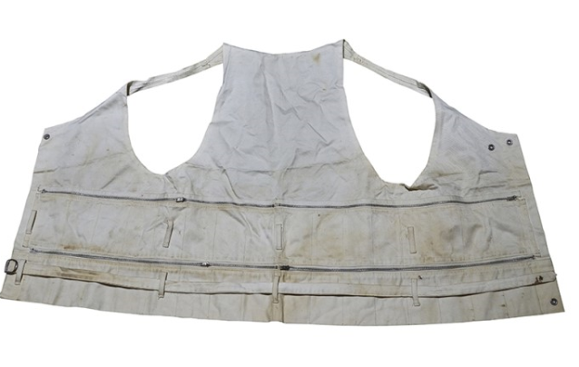 | This is a photograph of the specially-made vest worn by founder Ho Yew Ping during World War II, which contains multiple pockets for Ho to carry his gold while on the run.

- Tin Sing Goldsmiths
No. | Image | Caption
1 | 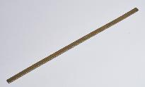 | This ruler, used by Tin Sing in the past, measures in traditional Chinese inches, which differ from the imperial standard.
2 | 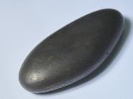  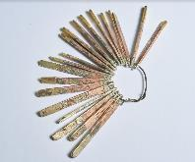 | Top: This touchstone is used to ascertain the purity of gold and silver by scraping pieces of jewellery against the stone and checking the colour of the residue (the more yellow the residue, the higher the purity).  Bottom: These gold samples of varying purity are used to cross check the results from the touchstone test.
3 | 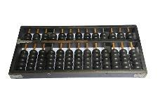 | This abacus set was used by Tin Sing’s employees in the past, and the clicking sound of abacus beads as sales staff calculated sale prices and tabulated earnings would fill the shop.
4 | 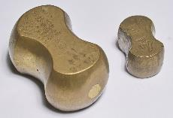 | These weights were once used to measure the weight of gold and jewellery pieces, and the serial numbers engraved on their backs indicate how often the weights were serviced and checked for accuracy.
5 | 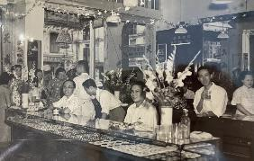 | This photograph, taken around the 1950s-1960s, shows crowds of buyers at Tin Sing, one of the most popular gold and jewellery shops along South Bridge Road.
6 | 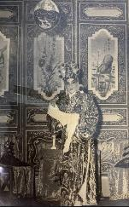 | This photograph, taken during the 1950s, shows a gold medallion crafted by Tin Sing and commissioned by a Cantonese opera fan for his or her idol.

- Kim Poh Hong Goldsmith
No. | Image | Caption
1 | 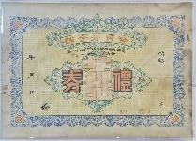 | This wedding gift voucher issued in the 1950s by Kim Poh Hong was commonly purchased by family members as gifts to newlyweds.
2 | 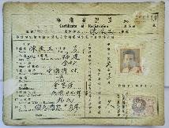 | This is the Certificate of Registration of Tan Eng Geok, founder of Kim Poh Hong, when he immigrated to Singapore in 1938 with his family.
3 | 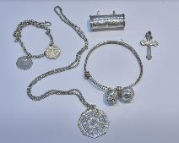 | These silver accessories, sold by Kim Poh Hong in the 1950s, are gifts to bless newborns, and they include (clockwise from the top) an anklet and bangle, an octagonal trigram for Taoists, a crucifix for Christians and an amulet holder for Taoists and Buddhists.
4 | 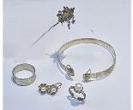 | These burial accessories, sold by Kim Poh Hong in the 1950s, include (clockwise from the top) Di Zhang Wang’s (Ksitigarbha Bodhisattva) sceptre, Buddha’s hands bangle, a pair of earrings, a ring inset with pearls and chap sa gor (13-band ring), which represents the lunar months in a year.
5 | 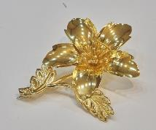 | This gold hibiscus flower brooch was sold by Kim Poh Hong in the 1950s. Such brooches were commonly worn by grooms on their wedding day in the past.
6 | 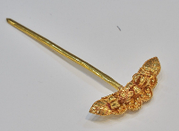 | This reddish gold hairpin was crafted by Kim Poh Hong in the 1950s, and the engravings of chrysanthemum flowers represent both fortune and luck.
7 | 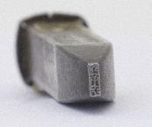 | This stamp, engraved with the Chinese characters “金宝芳” (Kim Poh Hong), was used to imprint the company’s name onto its jewellery as a mark of assurance.

- Bee Cheng Hiang
No. | Image | Caption
1 | 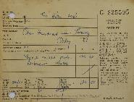 | This receipt was issued in 1972 by the Singapore government for Bee Cheng Hiang’s food licence application to operate the branch at New Bridge Road.
2 | 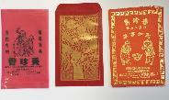 | These red packets were produced by Bee Cheng Hiang over the years as giveaways with purchases of bak kwa as a form of marketing collateral to raise awareness of the brand.
3 | 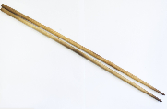  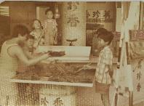 | Top: This pair of chopsticks was used in the past to flip bak kwa slices during the barbecuing process, as can be seen in the photograph below.  Bottom: This photograph, taken in the 1970s, shows employees barbecuing bak kwa at the New Bridge Road outlet, with the current third-generation owner and his mother in the middle.
4 | 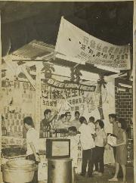 | This photo, taken between the 1960s and 1970s, shows Bee Cheng Hiang taking part in a trade fair as part of its marketing strategy to reach out to new customers and boost sales.
5 | 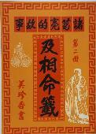 | This traditional divination manual reprinted in 1967 by Bee Cheng Hiang was given away free with bak kwa purchases at the National Day Exposition as Teo was interested in divination and felt that the knowledge of divination readings would benefit his customers as well.
6 | 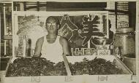 | This photograph of Teo Swee Ee, founder of Bee Cheng Hiang, was taken around 1950s-1960s against the shop sign which he designed.

- Lim Chee Guan
No. | Image | Caption
1 | 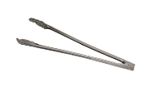 | This pair of tongs was used to flip slices of meat during the barbecuing process as it was easier to wield compared to wooden chopsticks, which were used in the past.
2 | 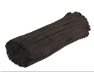 | Charcoal is used as fuel for barbecuing semi-dried meat slices, which gives bak kwa its distinctive smoky taste.
3 | 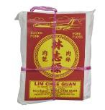 | This old paper package, tied with raffia string, features an earlier version of the company’s iconic aeroplane logo, which symbolises Lim Chee Guan’s aspirations to go international.
4 | 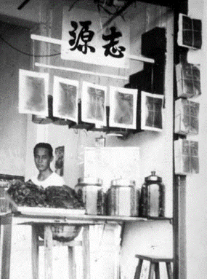 | This photograph, taken in the 1960s, shows founder Lim Kay Eng at his shop with an improvised barbecue pit in the foreground comprising a metal basin placed on top of a wooden stand.
5 | 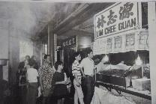 | This photograph, taken in the 1980s, captures a long queue of customers at Lim Chee Guan, which continues to be a common sight during festive periods such as the Lunar New Year.
6 | 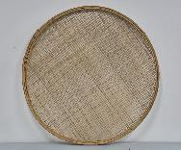 | Traditional bamboo sieves, such as the one shown in the photograph, are used by Lim Chee Guan for the drying of marinated meats.

- Tong Heng
No. | Image | Caption
1 | 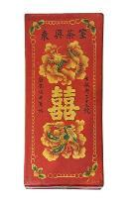 | This custom-made gift box was used to contain wedding jewellery and delivered as part of the package when customers ordered wedding confectioneries.
2 | 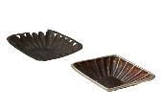 | Left: Tong Heng used to bake its egg tarts in various shapes before settling on the iconic diamond in the 1970s, using moulds such as the one shown in this image.  Right: This is the egg tart mould used today, which is slightly larger and deeper to hold more filling.
3 | 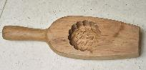 | This mooncake mould from the 1970s was custom-made by a master craftsman in Hong Kong for Tong Heng’s mooncakes.
4 |  | This document dated 1934 details the assets of Huang Hou Teahouse, such as bamboo baskets, tea sets and kettles, which were transferred to founder Fong Chee Heng.

- Pek Sin Choon
No. | Image | Caption
1 | 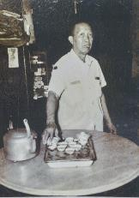  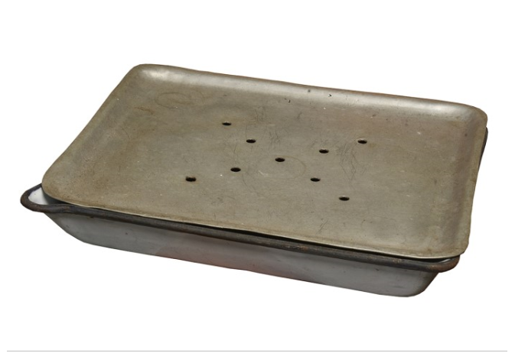 | Top: This is a photograph of founder Pek Kim Aw, taken in the 1960s, with the tea set used for sampling tea.  Bottom: This tea tray, also pictured in the photograph above, has holes in its upper layer while its lower layer functions as a container to hold water discarded in the process of tea brewing.
2 | 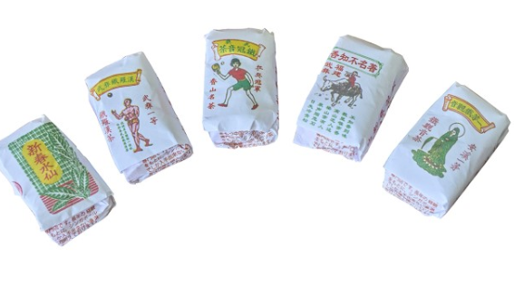 | These are Pek Sin Choon’s house blends with Nanyang flavours, and they comprise (from left to right): Sin Choon Shuixian, Wuyi Iron Arhat, Ping Pong Tie Guanyin, Renowned Unknown Fragrance and Tie Guanyin Grade 1.
3 | 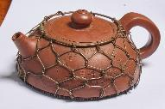 | This wire mesh was handmade by an elder in the family as a device to ensure even heat distribution in the teapot while brewing tea.
4 | 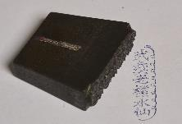  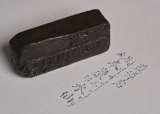  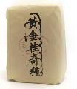 | These stamps were used to imprint each blend’s label onto tea packages and bear the names of Nanyang tea blends that Pek Sin Choon used to sell.

