MEDIA RELEASE
Information embargoed till the delivery of Ag Min/CCY’s speech at the award ceremony on 9 October 2025

42 LOCAL HERITAGE BUSINESSES RECOGNISED UNDER THE NATIONAL HERITAGE BOARD’S SG HERITAGE BUSINESS SCHEME

Singapore, 9 October 2025 – 42 heritage businesses have been recognised as SG Heritage Business awardees through the National Heritage Board (NHB)’s inaugural SG Heritage Business Scheme, designed to celebrate and raise awareness of heritage businesses as well as affirm their contributions as community and cultural anchors in Singapore. The awards ceremony was officiated by Guest-of-Honour Acting Minister for Culture, Community and Youth, David Neo, and brought together heritage business owners, community partners and members of the public to celebrate the diversity of heritage businesses and their contributions to Singapore’s cultural fabric.

2 The pilot iteration of the scheme was launched in March this year, and is one of the initiatives supported under the Inter-Agency Task Force for Heritage Businesses, Traditional Activities and Cultural Life. As a pilot, the scheme was open to locally owned businesses located in Singapore’s Central Area that have been operating for at least 30 years and have played an active role in shaping the character of their neighbourhoods, enriching the vibrancy of the city and safeguarding Singapore's heritage. Beyond longevity, their heritage significance, community contributions and innovation, as well as business sustainability efforts are also key to their successful nominations. The scheme provides support such as brand visibility through an SG Heritage Business mark on storefronts for ease of identification; inclusion in a directory on NHB’s heritage portal; features in placemaking efforts; and business consultancy services.

3 Awardees have also demonstrated their roles as community anchors, having engaged and contributed to the community in their own ways. For instance, Basheer Graphic Books is a beloved gathering ground for the art and design community, and is one of the founding bookstores of bookshop.sg, an initiative by local independent booksellers. Rumah Makan Minang is deeply involved in activities in Kampong Gelam, where its owner is part of the Kampong Gelam Alliance and the Sultan Mosque Management Board; it also does regular food donations during the Ramadan period. Tea Chapter, a teahouse in Chinatown, has sustained efforts to transmit the practices related to the making and sharing of tea, including through tea making and appreciation workshops which are a core part of its offerings.

4 Ms Melissa Tan, Director (Heritage Policy & Research), NHB, said: “Heritage businesses are the living embodiments of multi-cultural Singapore – they carry the skills, stories and spirit of Singaporeans across generations. Of the 42 heritage businesses that have been awarded, more than half are single-outlet, family-owned businesses, and more importantly, all of them are home-grown. Through the SG Heritage Business Scheme, we hope to recognise these businesses for their contributions, and support them in their efforts to stay relevant in today’s changing landscape. For every heritage business honoured today, many more are working tirelessly to continue their traditional craft or trade. They need the support of fellow Singaporeans. Safeguarding our living heritage is a collective effort, and we hope Singaporeans will continue to discover, appreciate and support these businesses by patronising them and considering them for your next meal or even gifts to family and loved ones.”

Taste of tradition: Honouring food heritage, one recipe at a time

5 Food has always been central to Singapore’s cultural identity, and this year’s awardees represent the flavours and practices passed down through generations. From family-run restaurants that safeguard traditional recipes to household brands and teahouses, these establishments are anchors to Singapore’s ever-evolving food scene.

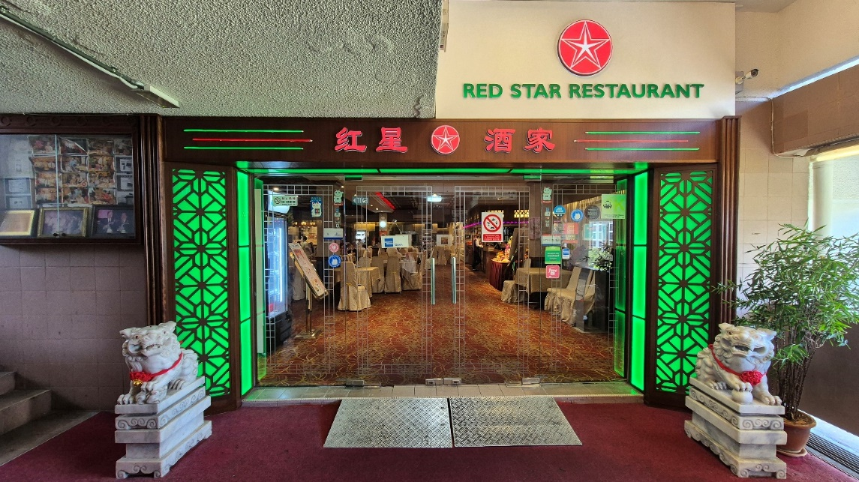
Red Star Restaurant

6 The scheme spotlights well-loved eateries that remain pillars of neighbourhoods and communities. Kamala Restaurant continues to draw loyal customers of all ages to its South Indian vegetarian fare, Sabar Menanti Nasi Padang preserves treasured Padang recipes in the heart of Kampong Gelam, while Red Star Restaurant has held on to the traditions of classic Cantonese dim sum dining for decades.

7 Alongside them, some of the iconic names that have been awarded include JUMBO Seafood, Koo Kee Yong Tow Foo Mee and Muthu’s Curry. These businesses demonstrate the ability for heritage to scale, highlighting their efforts at innovation while retaining their cultural core.

8 In recognising a diverse range of food businesses, the scheme aims to showcase the shared role they play in sustaining Singapore’s culinary heritage – be it by reaching millions, or by faithfully serving communities across generations.

Crafting continuity: Celebrating artisans and craftsmen that keep traditional skills alive

9 The scheme also shines a light on Singapore’s rich traditions of craft, design and artisanal skill. These include On Cheong Jewellery and Foundation Jewellers, where traditional goldsmithing and hand-crafted jewellery continue to play a role in life’s most significant milestones. Say Tian Hng Buddha Shop, a sixth-generation business, continues the craft of hand-carving and repairing Taoist deities, and has expanded it to the realm of art and design through participation in exhibitions and workshops.

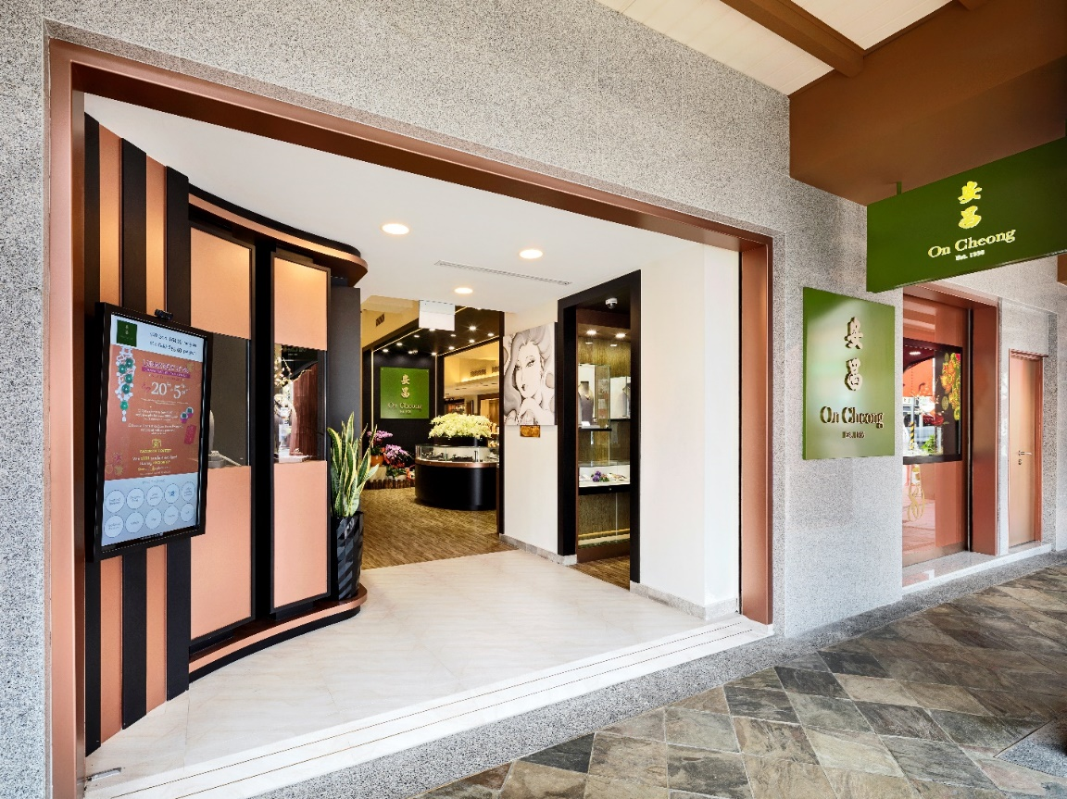
On Cheong Jewellery

10 In the realm of textiles, Dakshaini Silks and STYLEMART Bridal Collection remain trusted names for traditional fabrics and clothing, while CYC Company has been tailoring bespoke shirts and suits since 1935. Heritage bookstores such as Basheer Graphic Books, specialising in design and visual culture, and Maha Yu Yi, one of Singapore’s most established Chinese-language bookstores, represent cultural continuity through the written word. Together, these businesses safeguard craftsmanship, creativity and heritage knowledge.

Stewards of service: Businesses that serve with heritage at heart

11 The scheme also recognises service-oriented businesses that have shaped Singapore’s cultural and social fabric. Halijah Travels has guided generations of pilgrims on their spiritual journeys, while traditional medical halls such as Teck Soon Medical Hall and Thye Shan Medical Hall also carry on centuries-old practices of Chinese medicine, providing remedies rooted in traditional knowledge.

12 Other awardees include Cathay Photo Store, a pioneer in photographic equipment that has supported Singapore’s photography community since the 1950s Anushia Flower Shop, supplying fresh garlands for temple devotees, and VSS Varusai Mohamed & Sons, a long-standing purveyor of traditional pilgrimage services and goods in Kampong Gelam. Thandapani Company, a family-run spice business, provides spices and custom spice mixes which are essential for our local heritage cuisine. Together, these businesses highlight the many ways in which service and heritage intersect in everyday life.

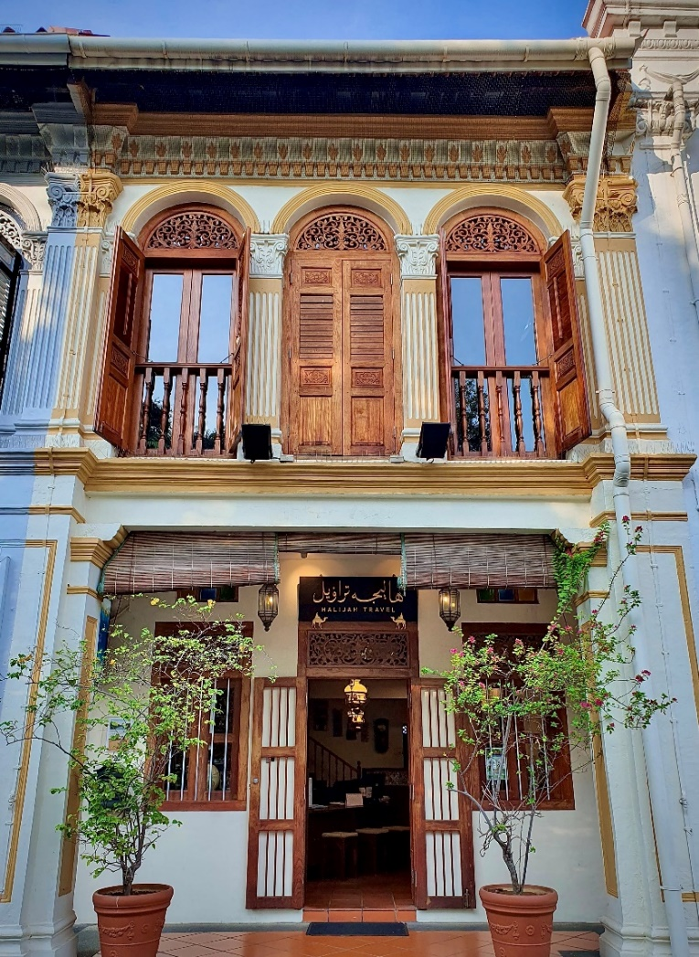
Halijah Travels

Safeguarding our heritage for future generations

13 Safeguarding our heritage is a collective effort, and the SG Heritage Business Scheme aims to raise awareness of longstanding heritage businesses and encourage Singaporeans to support these establishments. By honouring their longevity and enduring role in keeping our traditions alive, NHB hopes to foster a greater appreciation for these businesses and promote greater support as they preserve and pass on our heritage for generations to come.

14 For more information on the scheme and the awardees, please refer to:

- Annex A: For the full list of awardees
- Annex B: For quotes by some of the awardees
- Annex C: For images of SG Heritage Business mark and collaterals as part of the marketing toolkit provided to awardees
- NHB’s website: For more information on the SG Heritage Business Scheme

– END –

For media enquiries, please contact:
Gabrielle Lee  Tate Anzur  9040 4813  gabrielle.lee@tateanzur.com | Jia Xuan Seah  Tate Anzur  9617 4343  jiaxuan.seah@tateanzur.com

About National Heritage Board
The National Heritage Board (NHB) was formed on 1 August 1993. As the custodian of Singapore’s heritage, NHB is responsible for telling the Singapore story, sharing the Singaporean experience and imparting our Singapore spirit.

NHB’s mission is to preserve and celebrate the shared heritage of our diverse communities, for the purpose of education, nation-building and cultural understanding. It manages the national museums and heritage institutions, safeguards and promotes intangible cultural heritage, and sets policies relating to heritage sites, monuments and the national collection. Through the national collection, NHB curates heritage programmes and presents exhibitions to connect the past, present and future generations of Singaporeans. NHB is a statutory board under the Ministry of Culture, Community and Youth. Please visit www.nhb.gov.sg for more information.

ANNEX A

Full list of awardees of the SG Heritage Business Scheme 2025

- ANA Book Store  - Anushia Flower Shop  - Basheer Graphic Books  - Cathay Photo Store (Pte) Ltd  - Chatterbox  - Chop Wah On  - CYC Company Pte. Ltd.  - Dakshaini Silks Pte Ltd  - Foundation Jewellers Pte Ltd  - Gandhi Restaurant  - Gayatri Restaurant  - Halijah Travels Pte Ltd  - JUMBO Seafood  - Kamala Restaurant  - KELE  - Komala Vilas Vegetarian Restaurant  - Koo Kee Yong Tow Foo Mee  - Lim Chee Guan Pte Ltd  - Maha Yu Yi Pte Ltd  - Mei Heong Yuen Dessert  - Muthu's Curry  - Old Chang Kee Singapore Pte. Ltd.  - On Cheong Jewellery  - Pek Sin Choon Pte Ltd  - Red Star Restaurant Pte Ltd  - Rumah Makan Minang  - SABAR MENANTI NASI PADANG  - Say Tian Hng Buddha Shop  - Shashlik Restaurant  - SIS Premium Meats  - SPRING COURT RESTAURANT PTE LTD  - STYLEMART Bridal Collection Pte Ltd  - Swee Choon Tim Sum Restaurant  - Tai Chong Kok  - Tea Chapter  - Teck Soon Medical Hall Pte Ltd  - Thandapani Company Pte Ltd | - Thye Shan Medical Hall Pte Ltd  - Toko Aljunied  - Tong Heng Delicacies  - V S S Varusai Mohamed & Sons  - Yixing Xuan Teahouse

ANNEX B

Quotes from selected awardees of the SG Heritage Business Scheme 2025

Awardee | Quote
Chop Wah On | Mr Tong Kok Wing, Director, Chop Wah On, said: "Since its founding by Tong Chee Leong in 1916, Chop Wah On has been a family business, now proudly led by the third generation. The trust built with our customers and partners over the last century is the foundation of our pride and success. Honoured as a pioneer recipient of NHB’s SG Heritage Business Award, we have been crafting only "best-in-class" products for the past century. And will continue with the same commitment in the years to come.”
Gayatri Restaurant | Mr Shanmugam Ganesan, Founder and Owner, Gayatri Restaurant, said: “When my textile business started to decline and I was pushed into a corner, it brought out a different side of me — one that turned to my mother’s recipes for strength and inspiration. Even today, at 82, she continues to guide our chefs and shape the authentic flavours that define Gayatri. What started in 1996 as a small dream my wife and I built with determination has grown into a proud family legacy. It’s a true honour to be recognised with this prestigious award and knowing that my two sons now carry the same passion forward, keeping Gayatri’s heritage alive, makes it even more meaningful.”
Halijah Travels | Mr Haffidz Abdul Hamid, General Manager, Halijah Travels, said: “Indeed, we are deeply honoured to receive recognition as a heritage business. Although managing a travel agency is primarily running a business, we are also involved in managing and fulfilling the religious and spiritual pursuits of the community. Therein, the need to moderate business interests with compassion and lots of empathy. It is also imperative to remind ourselves that the haj pilgrimage is a legacy business that will have to evolve but nonetheless remain anchored as faith-based travel. To be recognised as a heritage business would help in this objective.”
Yixing Xuan Teahouse | Ms Charlene Low, Director of Business Development, Yixing Xuan Teahouse, said: “My family and I are deeply honoured to receive the SG Heritage Business Award. This recognition affirms Yixing Xuan Teahouse’s role in preserving and sharing the rich traditions of Chinese tea culture in Singapore. We are grateful to the National Heritage Board for this acknowledgement and the trust and support of our patrons, partners, and friends who walk this journey with us. Let us continue to protect and celebrate our shared heritage, one cup of tea at a time.”

ANNEX C

Images of SG Heritage Business mark and collaterals, as part of the marketing toolkit provided to awardees

SG Heritage Business mark



Pull up banner
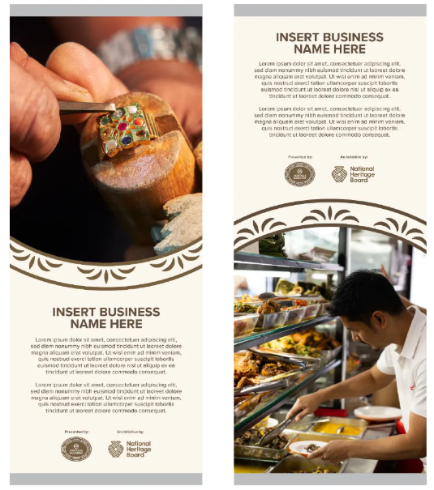

Wobbler


Social media template


This refers to the Central Area as set out by the Urban Redevelopment Authority (URA), and encompasses our major cultural, lifestyle and business precincts. This area is home to Singapore’s major cultural, lifestyle and business precincts, as well as a significant concentration of heritage businesses. Subsequent editions could cover heritage businesses in other areas of Singapore. Please refer to NHB’s website for more information.

