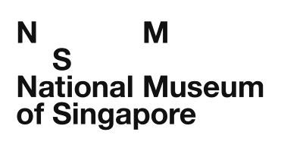
Attention: Education Department
Tel: 6332 3957 Email: nhb_nm_schools@nhb.gov.sg

Order Form for Early Learning Resources Booklets

School Name: ___________________________________________________________

School’s Sub BU Code (only applicable for MOE schools for e-invoice): _____________________________________

Contact Person : _____________________________ Designation: ______________________________________

Contact No. : __________________ (HP) _________________ (O) Email: _________________________________

Mailing Address: ________________________________________________________________________________

Description | No. of Sets (*Min 10 sets) | Unit Price (S$)
Early Learning Resources Booklets  Each set contains the following 3 booklets with gallery maps in a zip folder:  - “ABC: Early Learning at the National Museum”  - “123: Early Learning at the National Museum”  - “Colours: Early Learning at the National Museum”  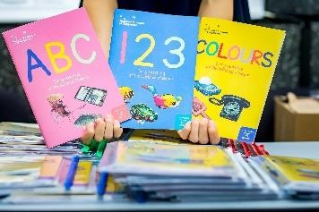 |  | $5 per set
*Purchase of less than 10 sets can be done at the NMS Museum Label Shop, retailing at S$8 per set.

Please indicate your preferred mode of delivery/collection. Collection is only available after the museum’s acknowledgment/receipt of full payment and by prior arrangement via email through nhb_nm_schools@nhb.gov.sg, during weekdays from 10am – 6pm.

- I would like TWO sets to be mailed to my school (complimentary postage), within 2 weeks of the museum’s acknowledgment/receipt of full payment. I will self-collect the remaining sets.

- I would like to self-collect ALL sets.

Please read through the following terms and conditions before endorsing this form below, and email the scanned copy to nhb_nm_schools@nhb.gov.sg to submit your order.
  - Orders will only be processed upon National Museum of Singapore’s acknowledgement/ receipt of the Order Form from the school and confirmation via email on the self-collection date. Please allow at least TWO (2) weeks for your order to be processed.

  - Schools can pay through electronic payment modes such as GIRO, bank transfer and credit cards. Payment instructions will be sent via email upon confirmation and delivery of your order by the National Museum of Singapore, an institution of the National Heritage Board (“NHB”). There will be no refund once payment is received.

  - The Early Learning Resources booklets have been designed for use at the National Museum of Singapore, as facilitated by a teacher/parent. Please note that NHB does not provide any facilitators at the National Museum of Singapore.

  - The school shall be fully responsible for any injury, loss or damage due to careless or other actions on the part of the teacher(s)/student(s) under their charge in relation to their visit at the National Museum of Singapore or use of the Early Learning Resources booklets, and NHB does not accept any liability in this regard.

  - Please email NHB_NM_Schools@nhb.gov.sg to notify NHB at least ONE month prior to your school’s intended visit if the group size is larger than 20 pax. Appointments are necessary for all group visits of more than 20 students, even if the visit is a self-guided tour to use the Early Learning Resources booklets.

  - Admission to NMS permanent galleries is free for students and teachers who are Singaporeans / PRs, as well as accompanying nonlocal teachers from MOE Kindergartens, Pre-School Anchor Operators and schools under NHB International Membership Scheme.

  - I also agree that the National Heritage Board may collect, use and disclose my personal data, as provided in this form, for the purposes of processing this order form and related administrative arrangements. Please write to NHB_NM_Schools@nhb.gov.sg for any queries or to withdraw consent to the collection, use and disclosure of your personal data.

By signing this form, I confirm that I have read, understood and accept the above terms and conditions.

Signature: ___________________________ For and on behalf of ___________________________ (School Name)

Date: ____________________________ School Stamp: ___________________________________________

Updated on 10 May 2019

