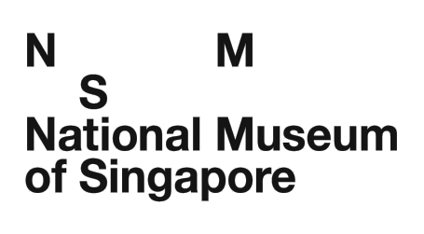
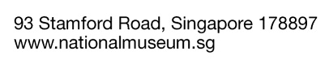

PROPOSED DONATION OF ITEM(S)

The National Museum of Singapore accepts donations of item(s) on a case-by-case basis. In order for the museum to assess the relevance of the proposed item(s) for the National Collection, please answer the questions below and attach at least two high resolution digital images (300dpi in jpeg format) of each proposed item with this document to NHB_NMS_Curatorial@nhb.gov.sg. Incomplete submissions will not be considered. Kindly indicate “N.A.” for questions that you are unable to answer. All information provided will be kept strictly confidential.

Name (Dr/Mr/Mrs/Mdm/Ms*): __________________________________________________

Designation: _______________________________________________________________

Company / Organisation: _____________________________________________________

Contact Numbers: _________________________(phone)_______________________(fax)

Email: ____________________________________________________________________

Address: __________________________________________________________________

*Please delete accordingly.

(Please attach a separate write-up if the space provided below is insufficient.)

1. Please provide a brief description of the item(s) and its current physical condition.

2. Where did the item(s) come from?

3. Who does the item(s) belong to? (Please include owner/s’ name/s and any other relevant

4. When did the owner acquire/own the item(s)?

5. Why did the owner acquire/own the item(s)?

6. How did the owner acquire/own the item(s)?

7. What is the historical value of this item(s)?

I would like my item(s) to be considered for donation to the National Museum of Singapore and hereby declare that the information provided is true and complete to the best of my knowledge and belief. This application is made in accordance with the Terms and Conditions stipulated by the National Museum of Singapore. I have read and understood the Terms and Conditions below and agree to abide by them.

_________________________
(Signature/Date)

Terms and Conditions

▪ The Museum reserves the right to refuse item(s) that do not fall within its mandate, jeopardise the conditions of the existing collection, subject the collection or the cultures from which they come to misrepresentation or disrespect, and/or item(s) deemed sacred or sensitive.
▪ No item(s) are to be donated to the Museum or deposited at the Museum without prior consent given by the Museum.

▪ The Museum reserves the right to request for additional information and photos of the item(s) before accepting the donation.

▪ Application for tax deduction for approved donations will require external valuation by recognised professionals at the donor’s own cost.
________________________________________________________________________

To be completed by National Museum staff only:

Date : ________________________________________________________________
Case No.: ______________________________________________________________________
Status: _________________________________________________________________________

