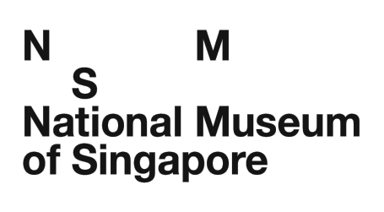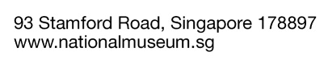

**PROPOSED DONATION OF ITEM(S)**

The National Museum of Singapore accepts donations of item(s) on a case-by-case basis. In order for the museum to assess the relevance of the proposed item(s) for the National Collection, please answer the questions below and attach at least two high resolution digital images (300dpi in jpeg format) of each proposed item with this document to NHB_NMS_Curatorial@nhb.gov.sg.Incomplete submissions will not be considered. Kindly indicate “N.A.” for questions that you are unable to answer. All information provided will be kept strictly confidential.

Name (Dr/Mr/Mrs/Mdm/Ms*): __________________________________________________

Designation: _______________________________________________________________

Company / Organisation: _____________________________________________________

Contact Numbers: _________________________(phone)_______________________(fax)

Email: ____________________________________________________________________

Address: __________________________________________________________________

*Please delete accordingly.

(Please attach a separate write-up if the space provided below is insufficient.)

1. **What is the item?**

*Briefly describe the item, including its name, manufacturer/maker details, and any features. Please attach (current) photos showing the front, back, and any details.*

1. **How was it used?**

*Tell us who used it, when and where it was used, and for what purpose. Include an old photo of it.*

1. **Why is it meaningful to you or your family?**

*Share any story, memory, or reason why the item matters to you.*

1. **How did you get it?**

*Was it inherited, found, bought, or given?*

1. **Anything else we should know?**

*This could include any unique or unusual features, its historical or social significance, or information about who made it and how it was produced. If you are unsure, you may simply write “not known.”*

I would like my item(s) to be considered for donation to the National Museum of Singapore and hereby declare that the information provided is true and complete to the best of my knowledge and belief. This application is made in accordance with the Terms and Conditions stipulated by the National Museum of Singapore. I have read and understood the Terms and Conditions below and agree to abide by them.

_________________________

(Signature/Date)

**Terms and Conditions**

▪ The Museum reserves the right to refuse item(s) that do not fall within its mandate, jeopardise the conditions of the existing collection, subject the collection or the cultures from which they come to misrepresentation or disrespect, and/or item(s) deemed sacred or sensitive.

▪ No item(s) are to be donated to the Museum or deposited at the Museum without prior consent given by the Museum.

▪ The Museum reserves the right to request for additional information and photos of the item(s) before accepting the donation.

▪  Application for tax deduction for approved donations will require external valuation by recognised professionals appointed by the Museum.

________________________________________________________________________

To be completed by National Museum staff only:

Date: _______________________________________________________________________

Case No.: _________________________________________________________________________

Status: _________________________________________________________________________